Name of Student : Raghav Mahesh Sarda PRN: 25070122235
Subject: Programming with Java Semester: III
ASSIGNMENT No : 5 Year: AY 2026-27
TITLE : Collection Classes and StringBuffer

Problem Statement
Develop a Java application demonstrating the use of ArrayList, Vector, and StringBuffer for dynamic data storage, management, and string manipulation.

Learning Objectives
To implement dynamic data storage and string manipulation using ArrayList, Vector, and StringBuffer.

Program:
ToDoList.java
// Assignment 5 - Exercise 1: To-Do List using ArrayList and StringBuffer
import java.util.*;
public class ToDoList
{
public static void main(String args[]) // Main method
{
Scanner sc = new Scanner(System.in);
ArrayList<String> tasks = new ArrayList<String>(); // ArrayList for dynamic task storage

System.out.print("Enter number of tasks: ");
int n = sc.nextInt();
sc.nextLine(); // Consuming leftover newline

for(int i=0; i<n; i++) // Loop to accept tasks
{
System.out.print("Enter Task " + (i+1) + ": ");
tasks.add(sc.nextLine()); // Adding user input to ArrayList
}

StringBuffer sb = new StringBuffer(); // StringBuffer for string manipulation
sb.append("\n- TO-DO LIST -\n"); // Appending header

for(int i=0; i<tasks.size(); i++) // Iterating through ArrayList
{
sb.append((i+1) + ". " + tasks.get(i) + "\n");
}

System.out.println(sb.toString());
sc.close();
}
}

StudentCourseRegistration.java
// Assignment 5 - Exercise 2: Course Registration using ArrayList and StringBuffer
import java.util.*;

public class StudentCourseRegistration
{
public static void main(String args[]) // Main method
{
Scanner sc = new Scanner(System.in);
ArrayList<String> courses = new ArrayList<String>(); // ArrayList to store courses dynamically

while(true) // Infinite loop for menu
{
System.out.println("\n1. Add Course 2. Remove Course 3. View Courses 4. Exit");
System.out.print("Enter choice: ");
int ch = sc.nextInt();
sc.nextLine(); // Consuming leftover newline

if(ch == 1) // Add condition
{
System.out.print("Enter Course Name to Add: ");
courses.add(sc.nextLine());
}
else if(ch == 2) // Remove condition
{
System.out.print("Enter Course Name to Remove: ");
courses.remove(sc.nextLine());
}
else if(ch == 3) // View condition
{
StringBuffer sb = new StringBuffer();
sb.append("\n=== Registered Courses ===\n"); // Appending header
for(int i=0; i<courses.size(); i++)
{
sb.append("- " + courses.get(i) + "\n"); // Appending course names
}
System.out.println(sb.toString());
}
else if(ch == 4)
{
break;
}
}
sc.close();
}
}

Output:
ToDoList.java
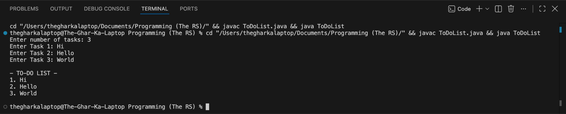

StudentCourseRegistration.java
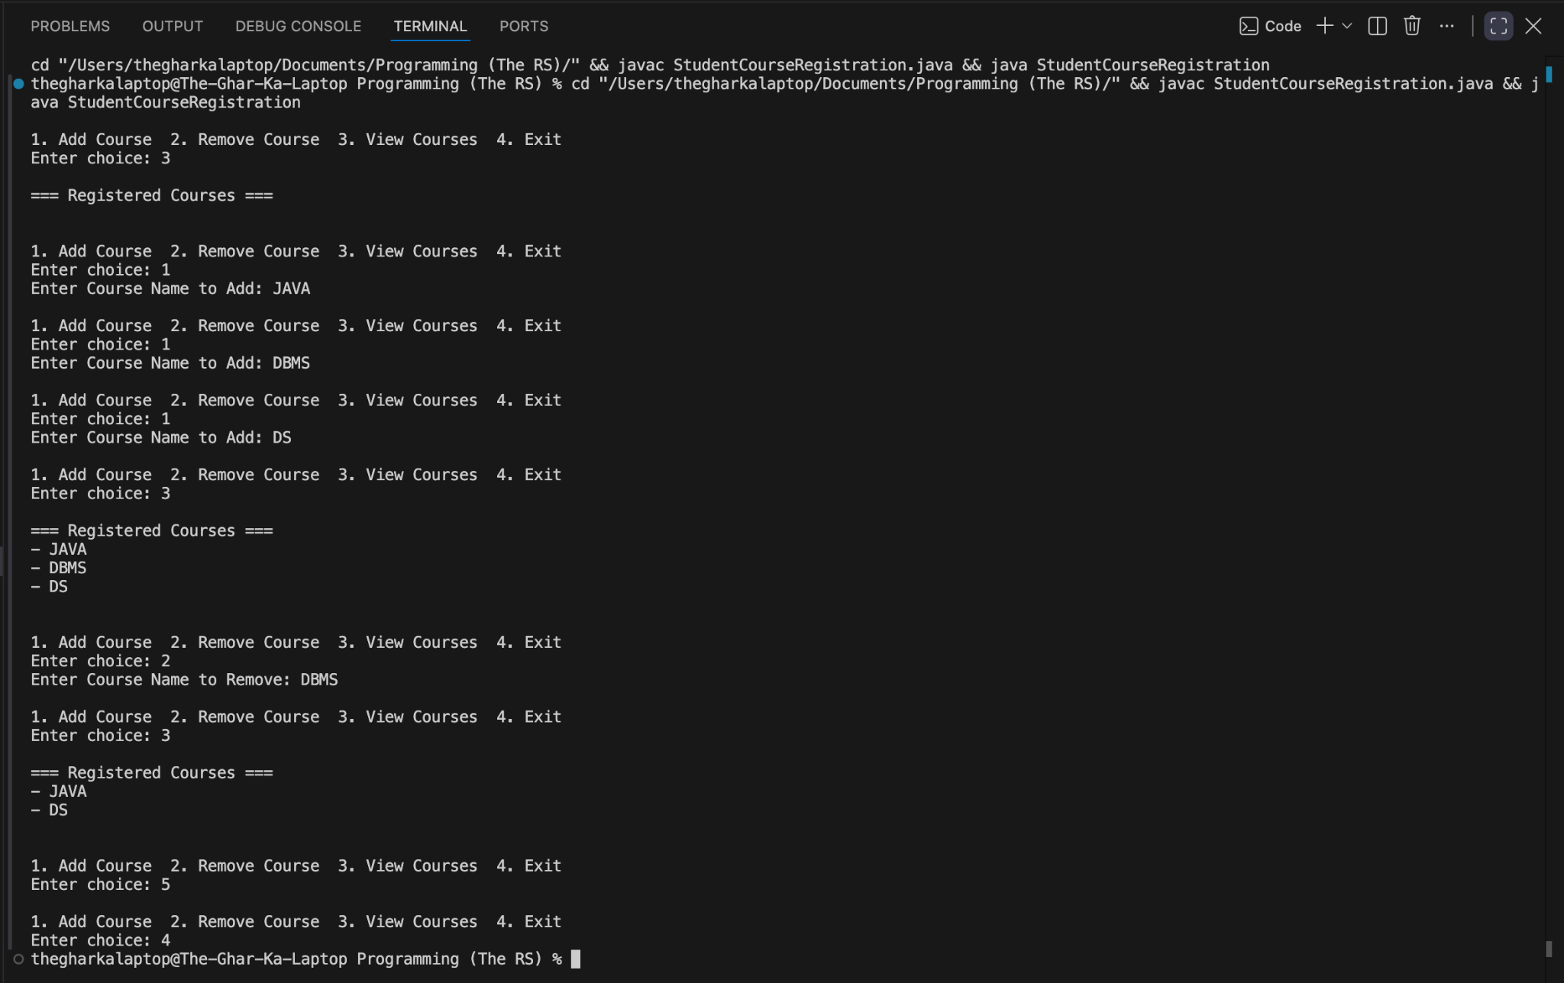

Conclusion:
In this assignment, concepts of dynamic memory management and string manipulation using ArrayList and StringBuffer were successfully implemented and verified. ArrayList provided flexible data structures for storing objects dynamically without fixed size limitations, and StringBuffer enabled efficient string concatenation and display formatting without creating unnecessary duplicate objects in memory.

